Design and Analysis of Algorithms CS575 Spring 2023

Theory Assignment 1

Due on 2/27/2023 (Monday)

Remember to include the following statement at the start of your answers with a signature by the side. “I have done this assignment completely on my own. I have not copied it, nor have I given my solution to anyone else. I understand that if I am involved in plagiarism or cheating I will have to sign an official form that I have cheated and that this form will be stored in my official university record. I also understand that I will receive a grade of 0 for the involved assignment for my first offense and that I will receive a grade of “F” for the course for any additional offense.”

**Yash Sanjay Makwana**

Please handwrite or type your answer to each question, scan or save your answers into a pdf file (with a vertical orientation so that we do not need to rotate your file to grade), and upload it to the homework submission site.

1. [20 points] Fill in all the missing values. For column A you need to compute the sums. For column B (the last two rows) you need to guess a function that does not contradict any of the yes/no answers already in the next three columns. Fill in each empty entry in the last three columns with either a yes/no answer.

|  |  |  |  |  |
| --- | --- | --- | --- | --- |
| Function | Function | O | Ω | θ |
| A | B | A = O(B) | A = Ω(B) | A = θ(B) |
| n4 | n3 lg n | No | Yes | No |
|  | n2 | Yes | No | No |
| (n + 1)! | n! | Yes | Yes | Yes |
| lg n | nk where k > 0 | Yes | No | No |
|  |  | Yes | Yes | Yes |
|  |  | No | Yes | No |

1. [20 points] Prove the following using the original definitions of O, Ω, 𝜃, o, 𝑎𝑛𝑑 𝜔.

(a) 3n3 + 50n2 + 4n - 9 ∈ O(n3)

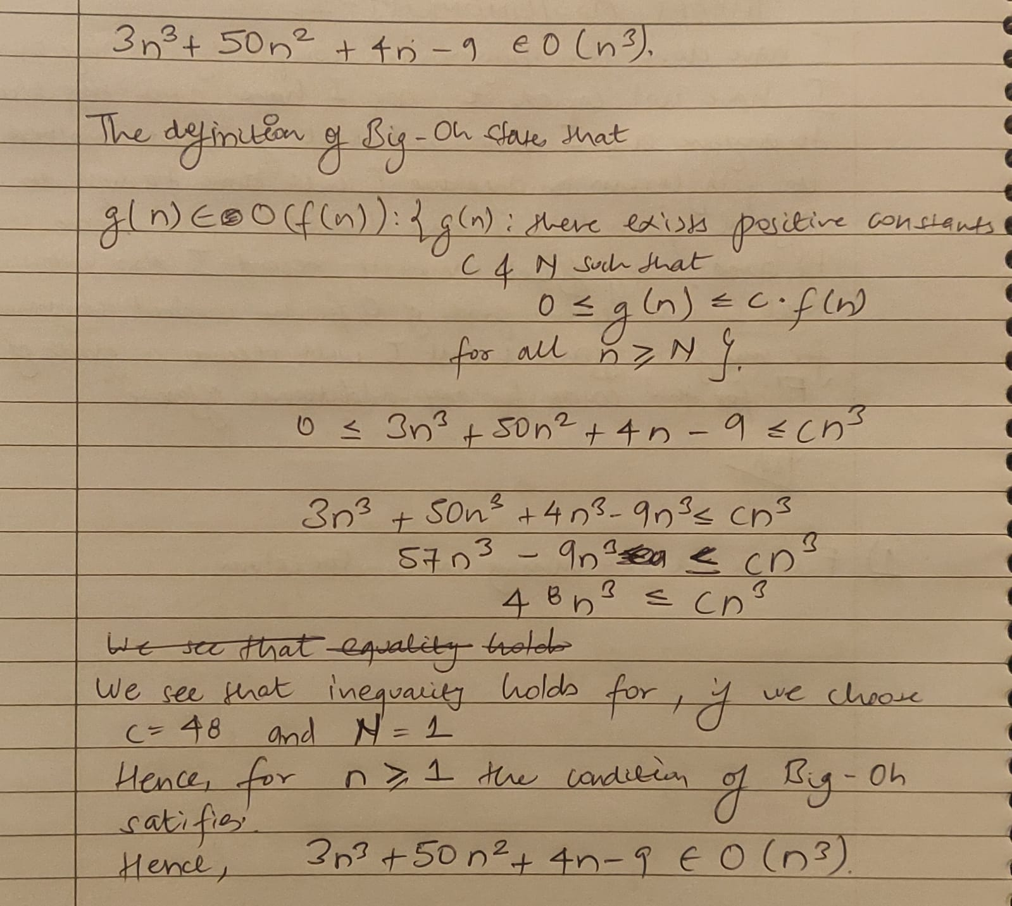

(b) 1000n3 ∈ Ω(n2)

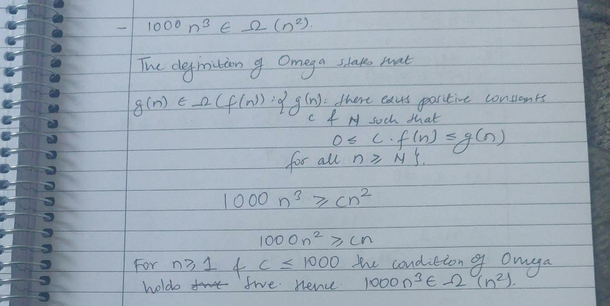

(c) 10n3 +7n2 ∈ 𝜔(n2)

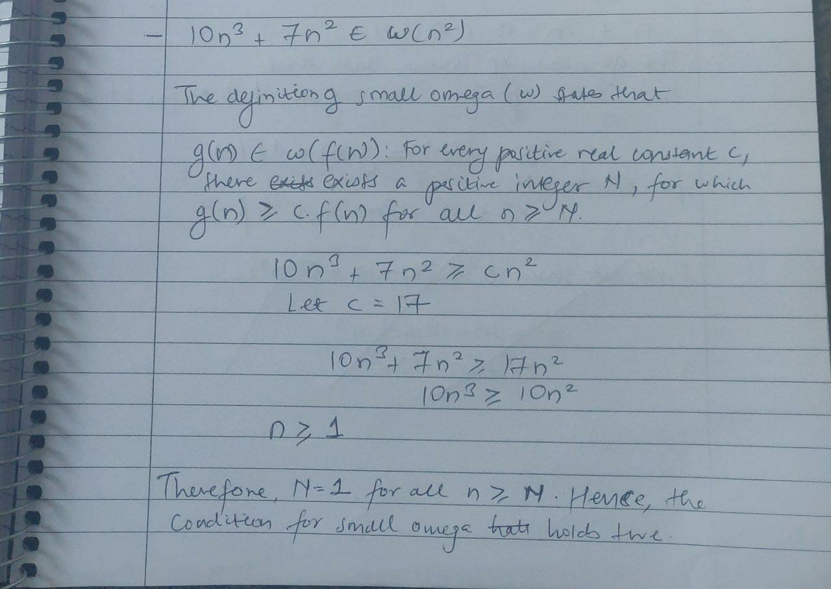

(d) 78n3 ∈ o(n4)

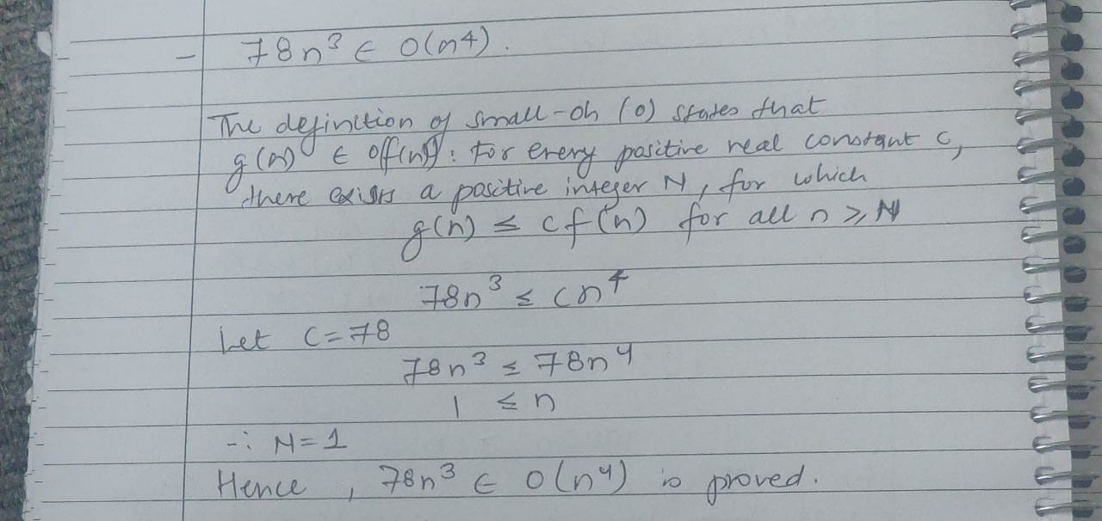

(e) *n*2 + 3*n* - 10 ∈ θ(*n*2 )

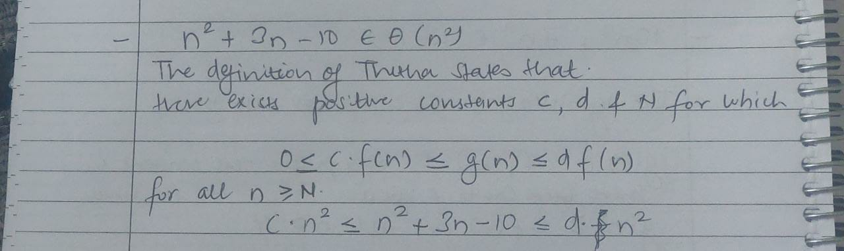

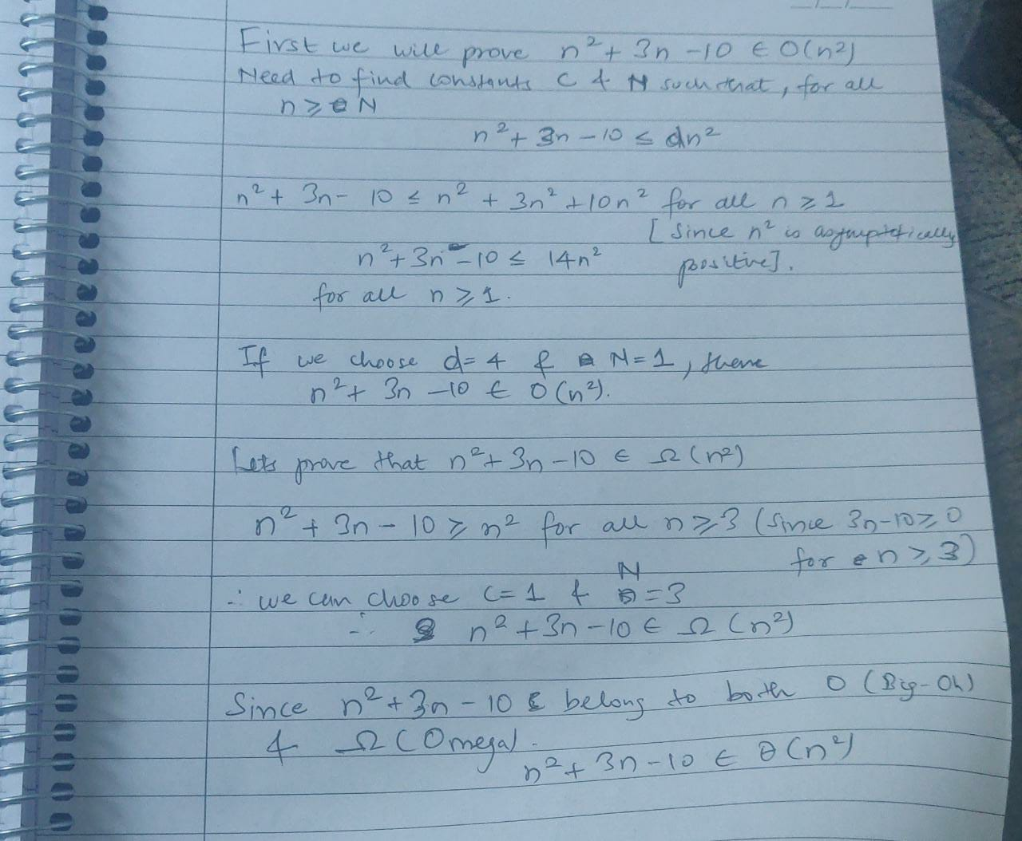

1. [15 points] Prove the following using limits.
   1. *n*1/*n* ∈ θ(1) [Hint: you can use x=elnx ]

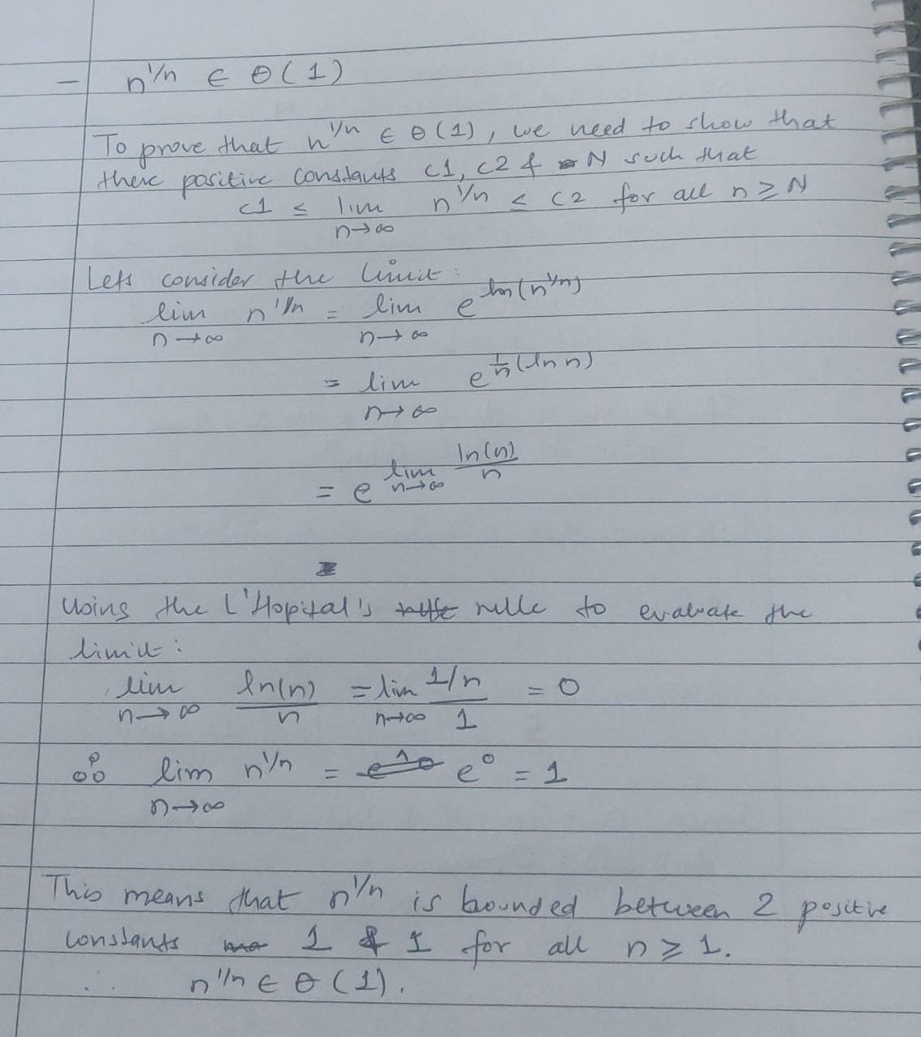

* 1. 4n ∈ 𝜔(nk)

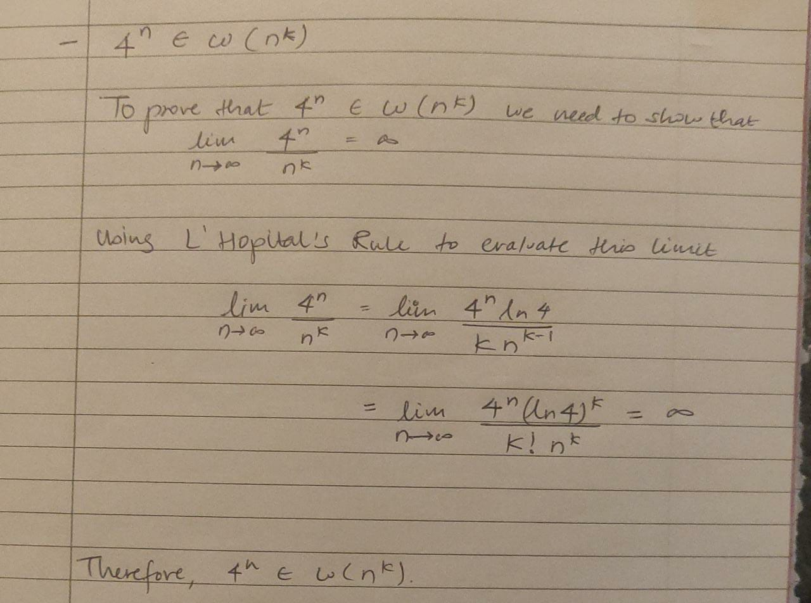

* 1. lg3n ∈ o(n0.5)

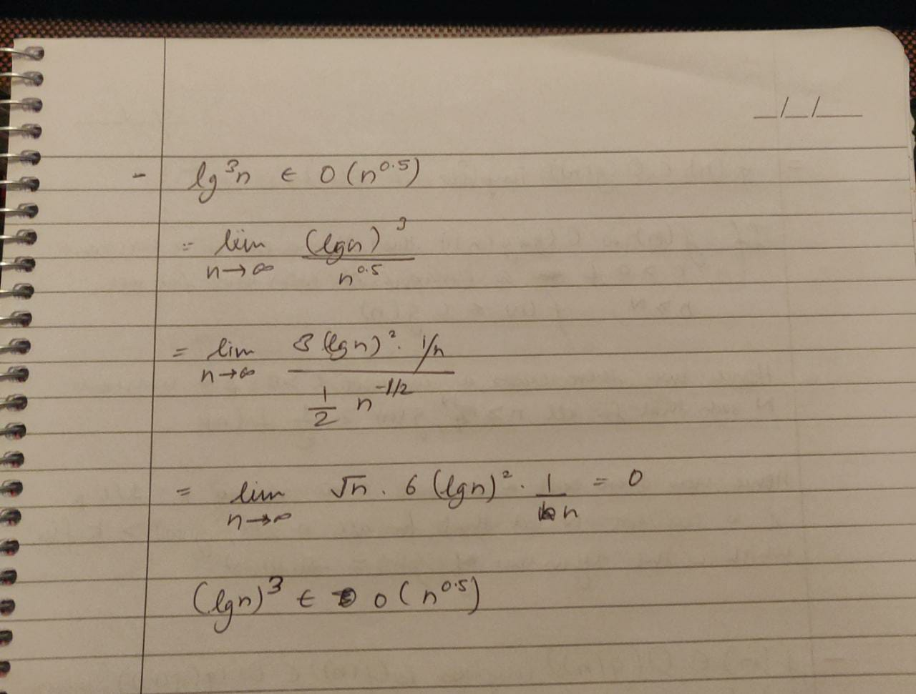

1. [10 points] Order the functions below by increasing growth rates (no justification required):

*nn*, *n*, *n* ln *n*, 𝑛1/2, 2lg*n*, ln *n,* 10, *n*1/*n*, √2lgn, *n*!, *lg(n10)*, 2*n*

Let *gi*(*n*) be the *i*th function from the left after the ordering (the leftmost function has the slowest growth rate). In the order, *gi*(*n*) should satisfy *gi*(*n*) ∈ *O*(*gi*+1(*n*)). If two or more functions are equivalent (in terms of Θ), put them in [ ] separated by comma (e.g., [*n*2, 5*n*2]).

Solution: 10, [ln(n), lg(n10) ], n1/n, [√2lgn , n1/2], [2lg*n,* n] , n ln(n), 2n, n! , nn

1. [20 points] Let *f*(*n*) and *g*(*n*) be asymptotically positive functions. For each of the following conjectures, either prove it is true or provide a counter example to show it is not true.
2. (𝑓(𝑛) + 𝑔(𝑛)) ∈ Θ(max(𝑓(𝑛), 𝑔(𝑛))).

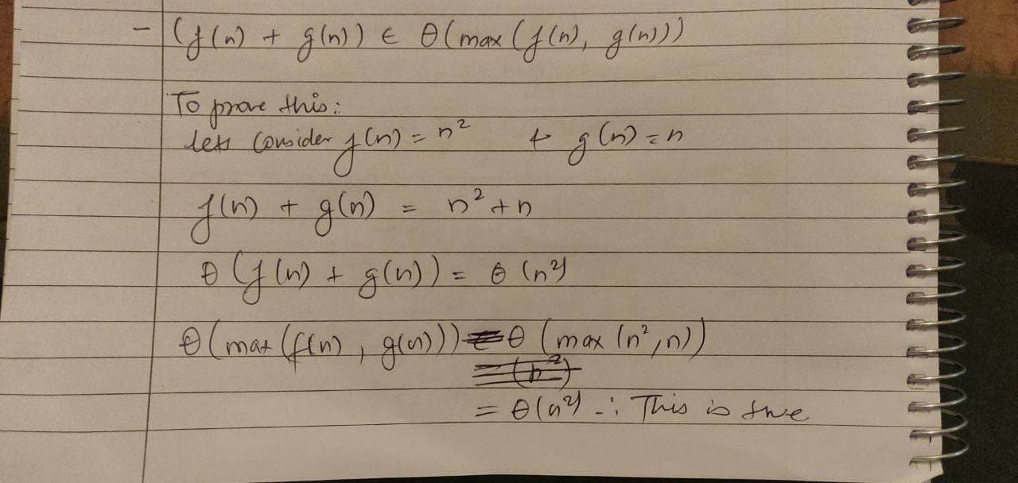

1. *f* (*n*) ∈ *O*(*g*(*n*)) implies 2 *f* (*n*) ∈ *O*(2*g*(*n*)).

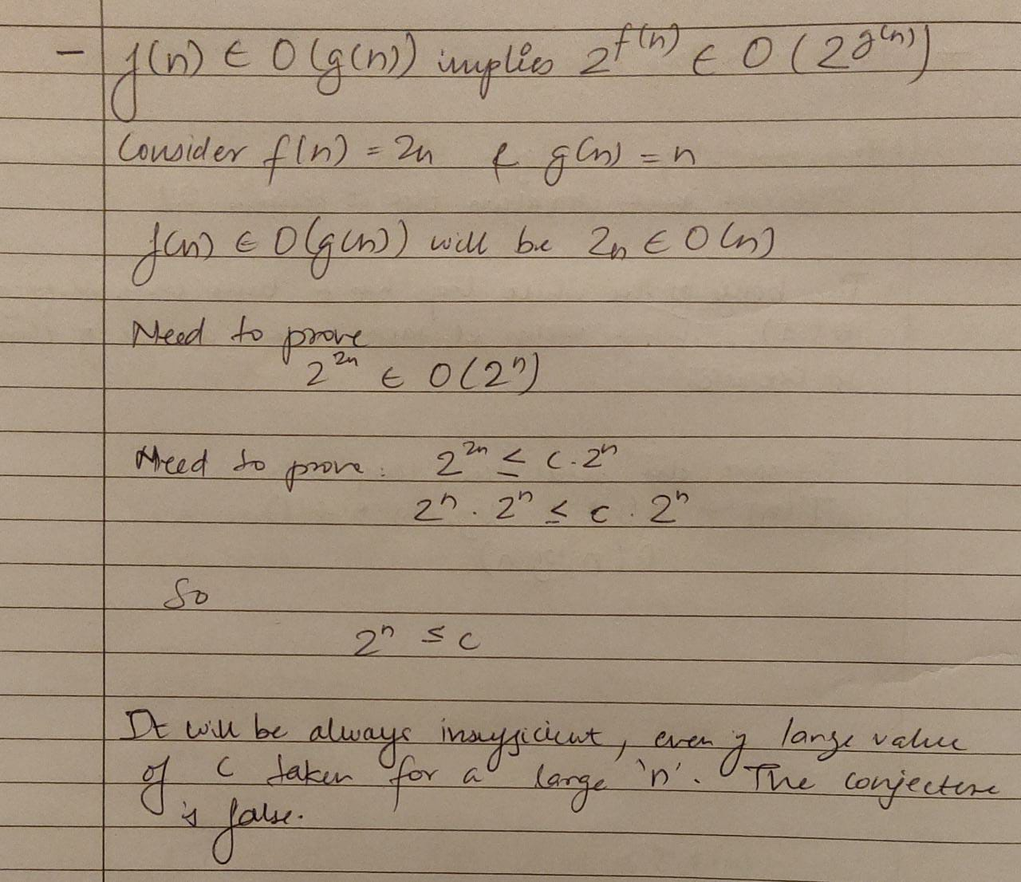

1. *f* (*n*) ∈ *O*(*g*(*n*)) implies *g*(*n*) ∈ Ω(*f*(*n*)).

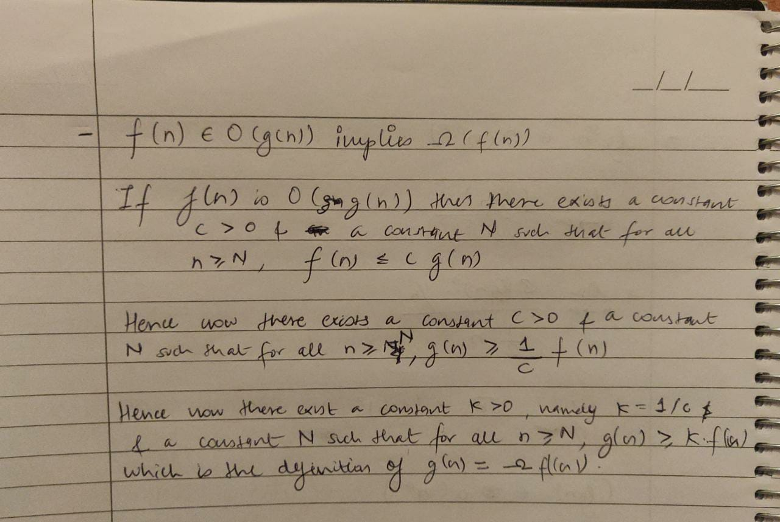

d. 𝑓(𝑛) ∈ 𝑂(𝑔(𝑛)) implies lg(𝑓(𝑛)) ∈ 𝑂(lg(𝑔(𝑛))), where lg(g(n)) ≥ 1 and 𝑓(𝑛)

≥1 for sufficiently large n.

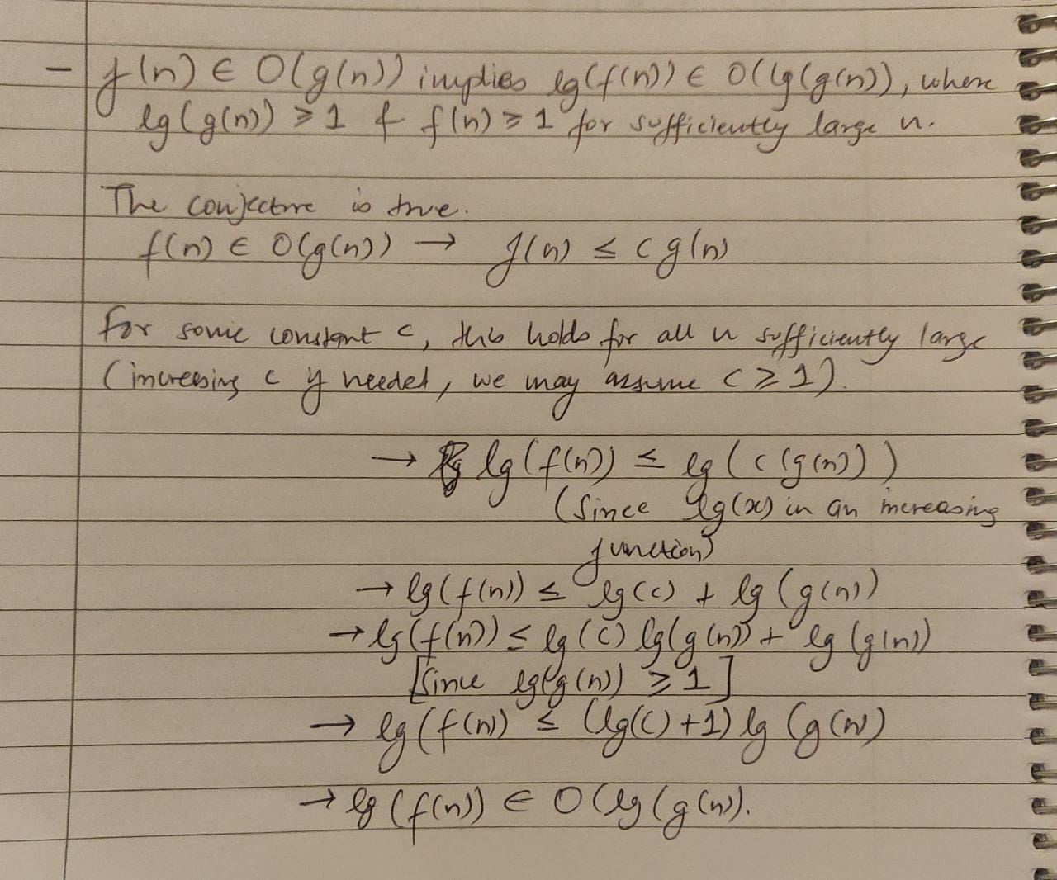

1. [10 points] Prove that for all integers n>0,

by mathematical induction. Divide your proof into the three required parts: Induction Base, Induction Hypothesis, and Induction Steps.

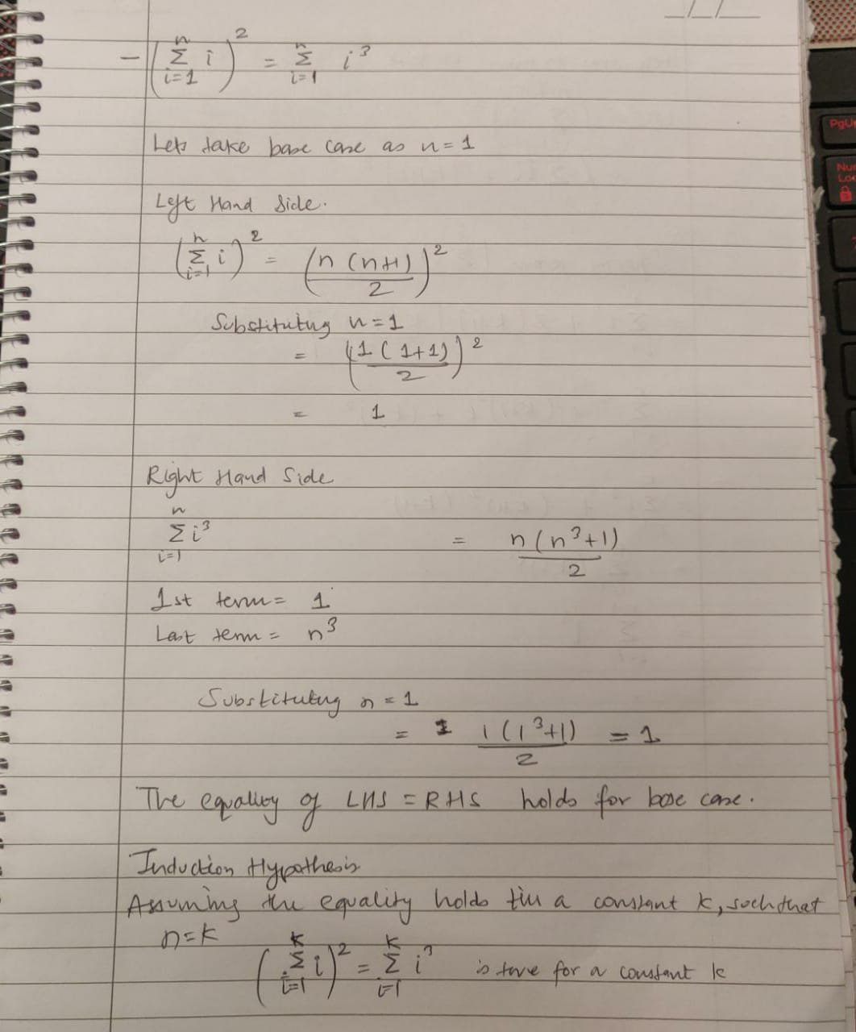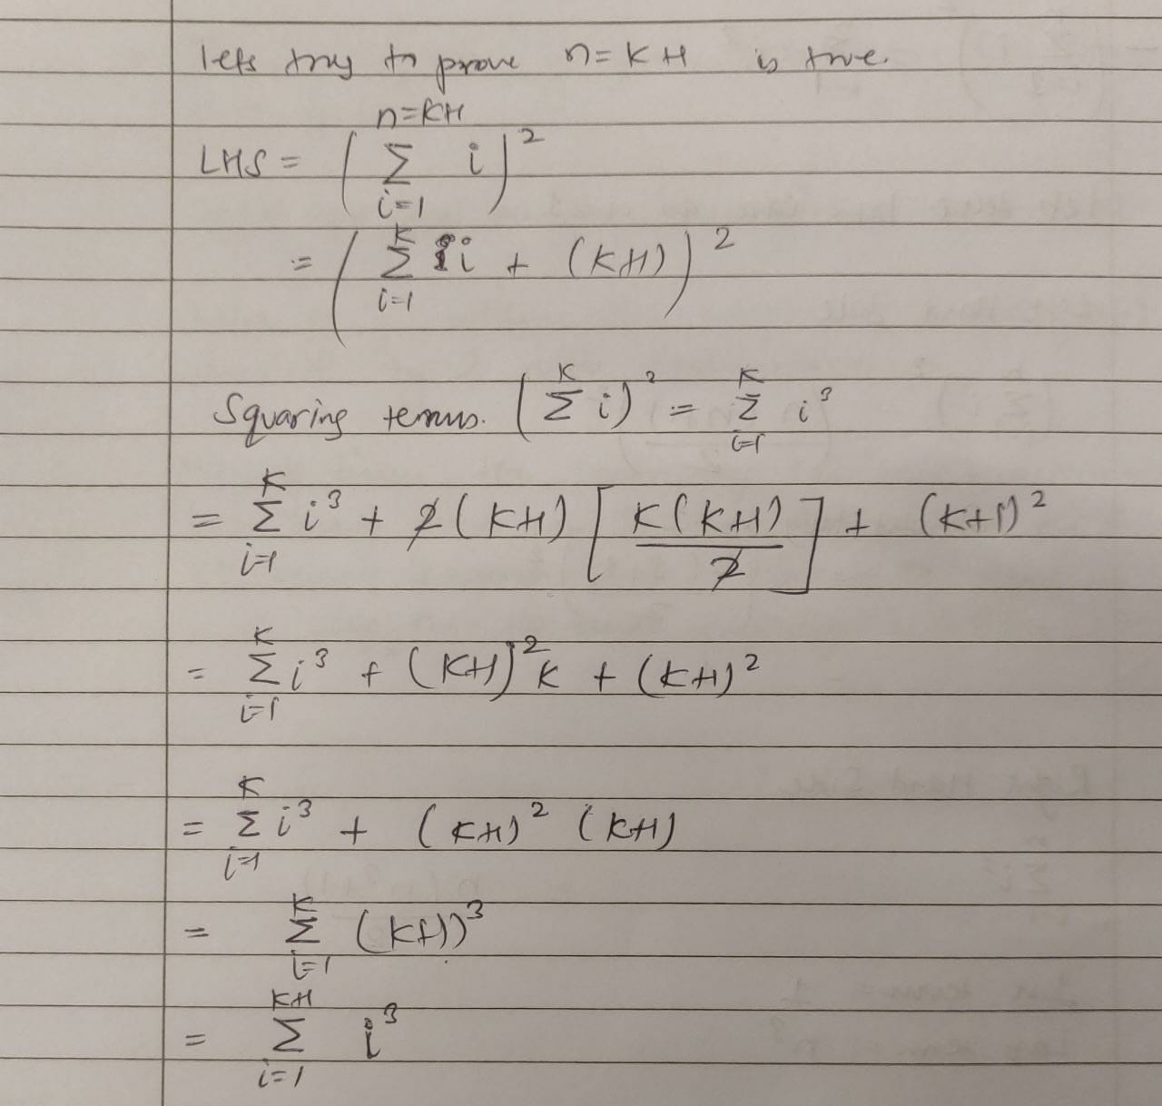

1. [15 points] Consider the following algorithm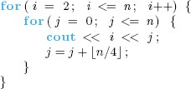
   1. What is the output when n=4?
   2. What is the time complexity T(n). You may assume that n is divisible by 4.

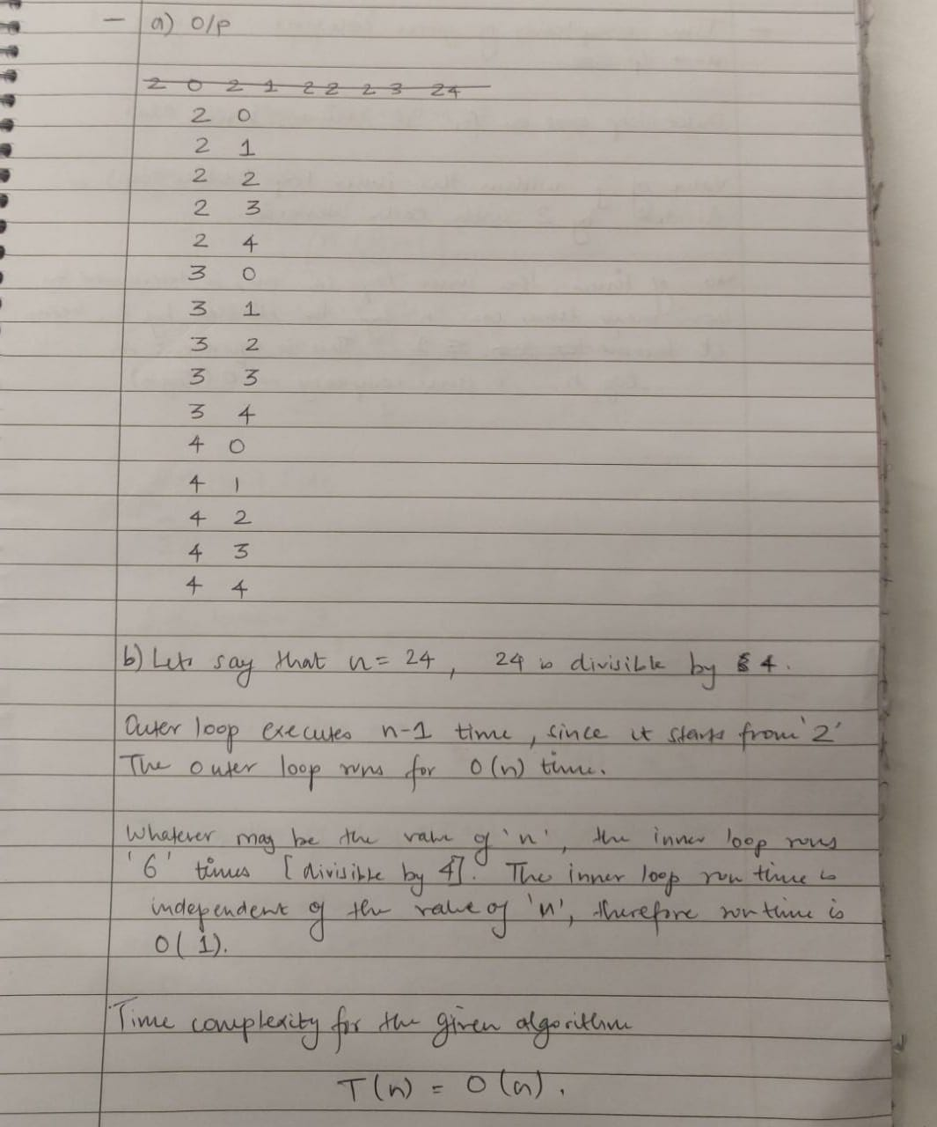

1. 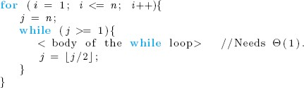[10 points] What is the time complexity T(n) of the nested loops below? For simplicity, you may assume that n is a power of 2. That is, n = 2k for some positive integer k. Give some justification for your answer.

